**Table 1**

Maximum Propagation Delays of the 74HCT00N, 74HCT04N, and 74HCT20N ICs at Vcc=4.5V

|  |  |  |  |
| --- | --- | --- | --- |
| Device | tPLH ns | tPHL ns | tPMAX ns |
| 74HC00N | 27 | 27 | 27 |
| 74HC04N | 26 | 26 | 26 |
| 74HC20N | 27 | 27 | 27 |

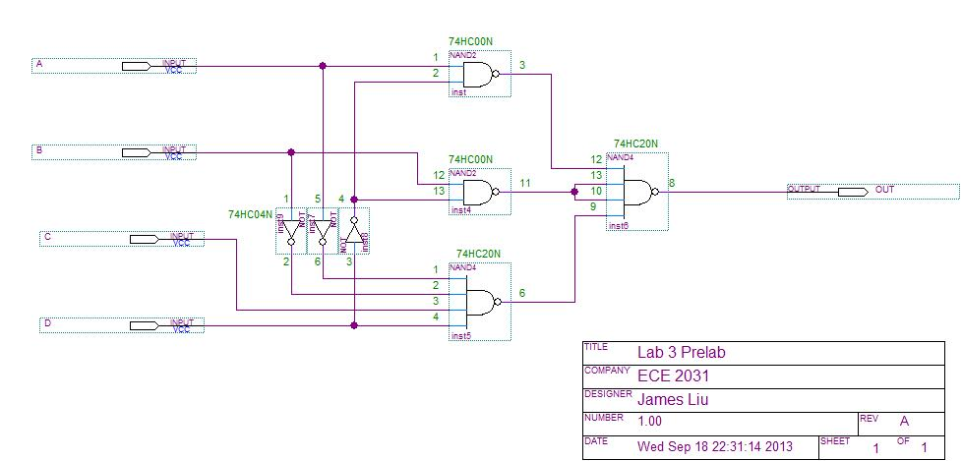

27ns

27ns

27ns

27ns

26ns

26ns

26ns

**Figure 1.** Schematic of Y = AD’+BD’+A’B’CD annotated with propagation delays and worst case propagation path.

**Table 2**

Truth Table of Y=AD’+BD’+A’B’CD with Highest Propagation Delays Highlighted

|  |  |  |  |  |
| --- | --- | --- | --- | --- |
| A | B | C | D | Y |
| 0 | 0 | 0 | 0 | 0 |
| 0 | 0 | 0 | 1 | 0 |
| 0 | 0 | 1 | 0 | 0 |
| 0 | 0 | 1 | 1 | 1 |
| 0 | 1 | 0 | 0 | 1 |
| 0 | 1 | 0 | 1 | 0 |
| 0 | 1 | 1 | 0 | 1 |
| 0 | 1 | 1 | 1 | 0 |
| 1 | 0 | 0 | 0 | 1 |
| 1 | 0 | 0 | 1 | 0 |
| 1 | 0 | 1 | 0 | 1 |
| 1 | 0 | 1 | 1 | 0 |
| 1 | 1 | 0 | 0 | 1 |
| 1 | 1 | 0 | 1 | 0 |
| 1 | 1 | 1 | 0 | 1 |
| 1 | 1 | 1 | 1 | 0 |

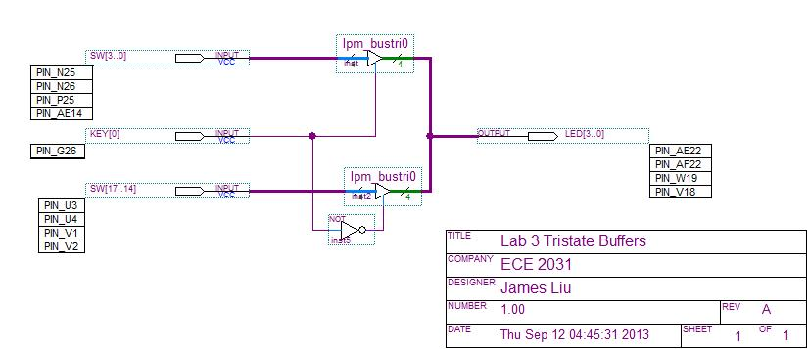

**Figure 2.** Schematic of tristate output buffer.

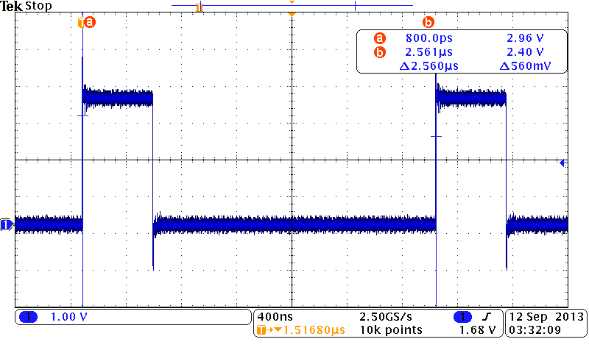

**Figure 3.** Osciliscope screen capture of period measurement of the Lab3-DE2.sof output with an input birthday of 07/07.

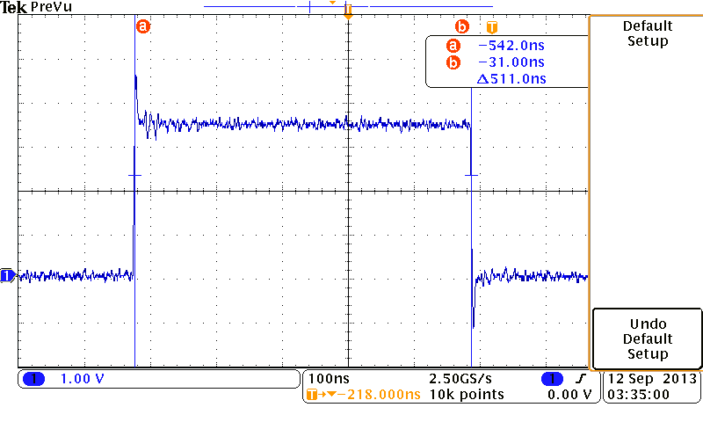

**Figure 4.** Osciliscope screen capture of positive duty cycle measurment of the Lab3-DE2.sof output with an input birthday of 07/07. Lab3-DE2 has a positive duty cycle of 20%.

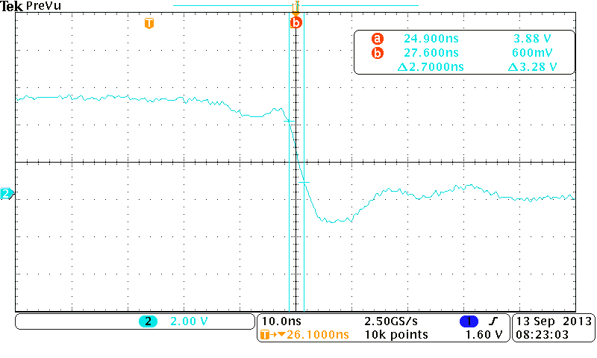

**Figure 5.** Oscilloscope screen capture of the fall time measurement of Y=AD’+BD’+A’B’CD implemented with HCT ICs.

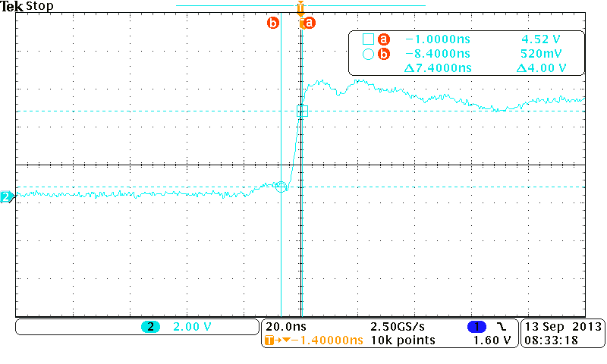

**Figure 6.** Oscilloscope screen capture of the rise time measurement of Y=AD’+BD’+A’B’CD implemented with HCT ICs.

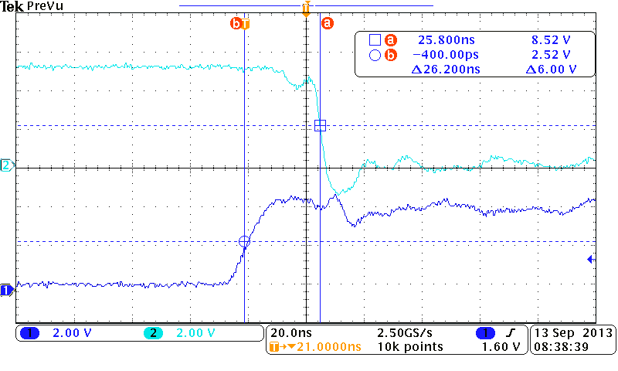

**Figure 7.** Oscilloscope screen capture of the low to high propagation delay of Y=AD’+BD’+A’B’CD implemented with HCT ICs.

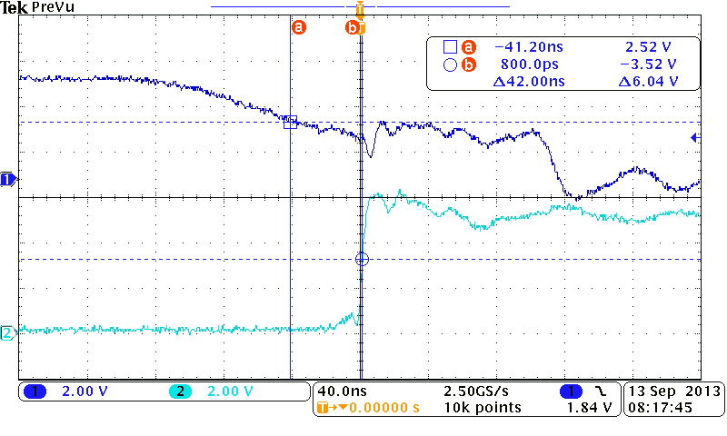

**Figure 8.** Oscilloscope screen capture of the high to low propagation delay measurement of the Y=AD’+BD’+A’B’CD implemented with HCT ICs.